

**School of Computer Science and Engineering**

DBMS Course Project Report

on

**Appliance Store Management System**

Submitted by

**Ms.AnushaRaikar 01FE18BCS043**

**Ms.ApoorvaJinde 01FE18BCS044**

**Ms.ArchanaBadagi 01FE18BCS045**

**Ms. Ashwini Banagar 01FE18BCS054**

**Table of Contents**

|  |  |  |
| --- | --- | --- |
| **S.no** | **Content** | **Pg. no** |
| 1. | Introduction | 3 |
| 2**.** | Proposal Phase   1. ER Diagram 2. ER to Relational Mapping 3. Data Dictionary | 4 |
| 3. | Design Phase   1. Design Phase 2. User Interface | 16 |
| 4**.** | Implementation Phase  i. SQL Queries  ii. Actual data stored in database   1. Bills ,Graphs snapshots | 20 |
| 5. | User Manual | 36 |
| 6 | Snapshots with client | 37 |
| 7 | Dataset Snapshots | **38** |
| 8 | Customer initial acceptance letter | **40** |
| 9 | Customer Feedback | **41** |

**Introduction**

We came across a problem that the shop has a huge collection of customer and supplier data which they were managing in ledgers and Excel sheets. They did not have any computerized system for now and the bill they generate was by entering the data in the cells of excel sheet. A lot of time is consumed during the process of business activity. And the customers who apply for AMC should be given services which they used to mark on calendar manually hence they would mess up having the wrong number of count of the services provided to customer. So we came up with the idea of providing them a computerized system to improve the efficiency and performance of their daily business activity.

**Proposal Phase**

KLETech/SoCSE(2019-20)/DBMS/15ECSC208/Course Project/Report/Page 2 of

**Responsibilities:**

**AnushaRaikar:**

Collection of all data from the clients required for the project.

ER to relational Mapping. Data Dictionary.

**ApoorvaJinde:**

Developing ER model for the management selected

ER to relational Mapping.Object Model

**ArchanaBadagi:**

Developing ER model for the management selected.

Collection of all data from the clients required for the project.

**AshwiniBanagar:**

Developing ER model for the management selected. Documentation

**Problem Description:**

We came across a problem that the shop has a huge collection of customer and supplier data which they were managing in ledgers and Excel sheets. They did not have any computerized system for now and the bill they generate was by entering the data in the cells of excel sheet. A lot of time is consumed during the process of business activity. And the customers apply for AMC should be given services which they used to mark on calendar manually hence they would mess up having the wrong number of count of the services provided to customer. So we came up with the idea of providing them a computerized system to improve the efficiency and performance of their daily business activity.

**Requirements:**

1) To maintain details of all the customers and employees.

2) Bill Generation

3) Notification to provide service to customer who have taken up AMC (Annual MaintenanceContract)

4)Proper security of data.

**Design Questions to be answered**

**Question 1:** From the problem description, identify the entities that need to be represented in the database, the attributes of each entity, the relationships between the entities, and the cardinality ratios of each relationship.

**Entities and Attributes**

1. **Shop**:
2. GST_NO
3. ShopName
4. Address
5. Location
6. **Employee:**
7. EmpId
8. E_Fname
9. E_Lname
10. Salary
11. Qualification
12. PhoneNo
13. AadharNo
14. JoinDate
15. Address
16. **Supplier:**
17. GST_no
18. DateOfSale
19. SName
20. PaidAmt
21. TotalAmt
22. PhoneNo
23. **Products:**
24. ProductId
25. Brand
26. ProductName
27. TotalQuantity
28. GSTAmt
29. TotalPrice
30. Features
31. **Bill:**
32. Bill_ID
33. BDate
34. PaidAmt
35. TotalAmt
36. PaymentMode
37. **Customer:**
38. CustId
39. C_FName
40. C_LName
41. PhoneNo
42. CustAddress
43. **AMC:**
44. RecNo
45. AMCQuantity
46. MaintenanceYears
47. TotalNoServices
48. NoOfServicesDone
49. LastService

Any number of employees can work for a single shop.Therefore, n:1 will be the cardinality ratio.Total participation by both employee and shop as every employee’s detail added to the table has to belong to the shop and the shop has to be there for the person to be as employee.

Each shop owns many products. Therefore, there is 1:n cardinality ratio.Total participation by both shop and products as there cannot be products which are not under the shop and there cannot the shop without no products.

Any number of suppliers supply any number of product, so there is n:m cardinality ratio.Total participation is by both supplier and products as products are brought by supplier and there can be no suppliers who provide no product thus we require supplier and product.

Many products can be brought under one bill. And one product can be brought by many bills. Therefore the cardinality is n:m. There is total participation of product as there cannot be bill without bill but there can be existence of product without bill hence bill is partial dependent.

Each customer can come multiple times to buy the shop and has many bills. Therefore there is 1:ncardinality ratio between customer and bill ,and total participation from both customer and bill, because if bill is generated then there must be a customer and if customer details are stored then there must be a bill generated.

As one AMC_No is specified for a particular number of products of the same kind if applied for one bill. Hence the cardinality ration b/w product and AMC is 1:1. There is total participation of the product as there can be no AMC without product but the AMC’s participation is optional as only the chosen products have AMC not mandatory all the products we purchase.

**Question 2:** Draw an Entity-Relationship Diagram illustrating the information you have identified in Question 1.

**1ST ER Diagram:**

KLETech/SoCSE(2019-20)/DBMS/15ECSC208/Course Project/Report/Page 6 of

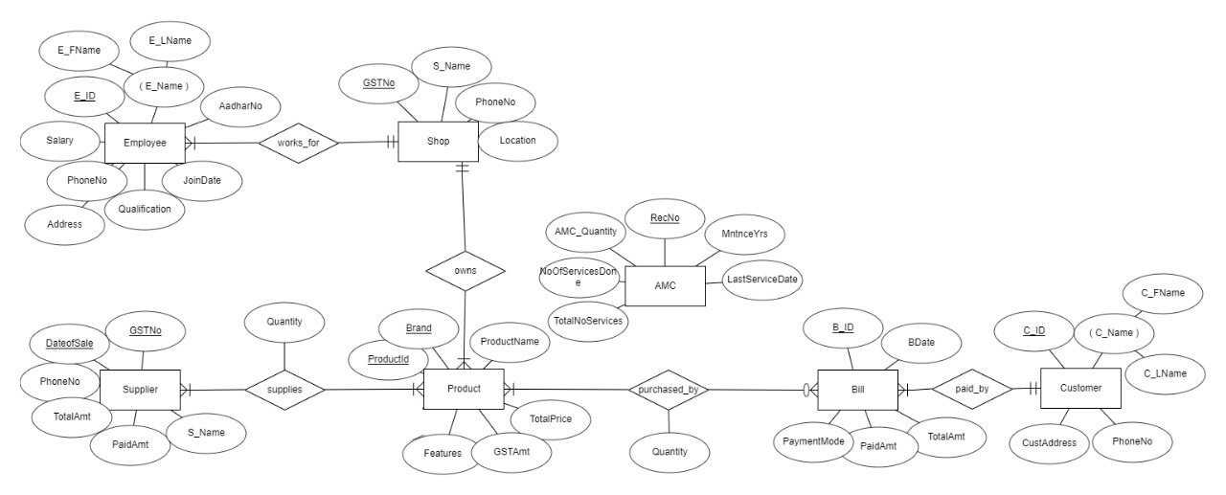

**Question 3:** Draw **alternate**Entity-Relationship Diagram illustrating the information you have identified in Question 1 that you think are most likely to occur.

**2nd ER Diagram:**

KLETech/SoCSE(2019-20)/DBMS/15ECSC208/Course Project/Report/Page 7 of

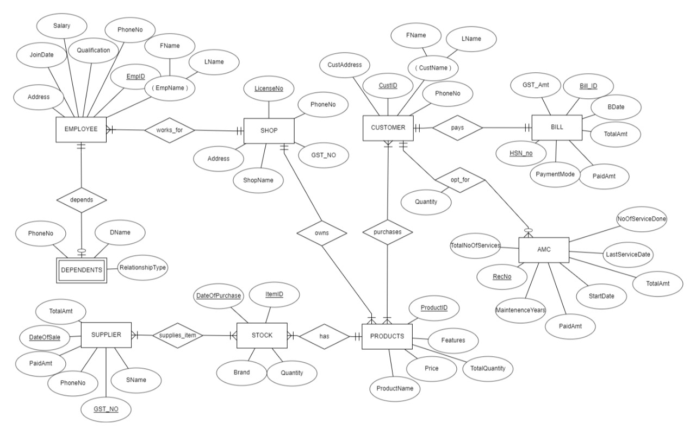

**3rd ER Diagram:**

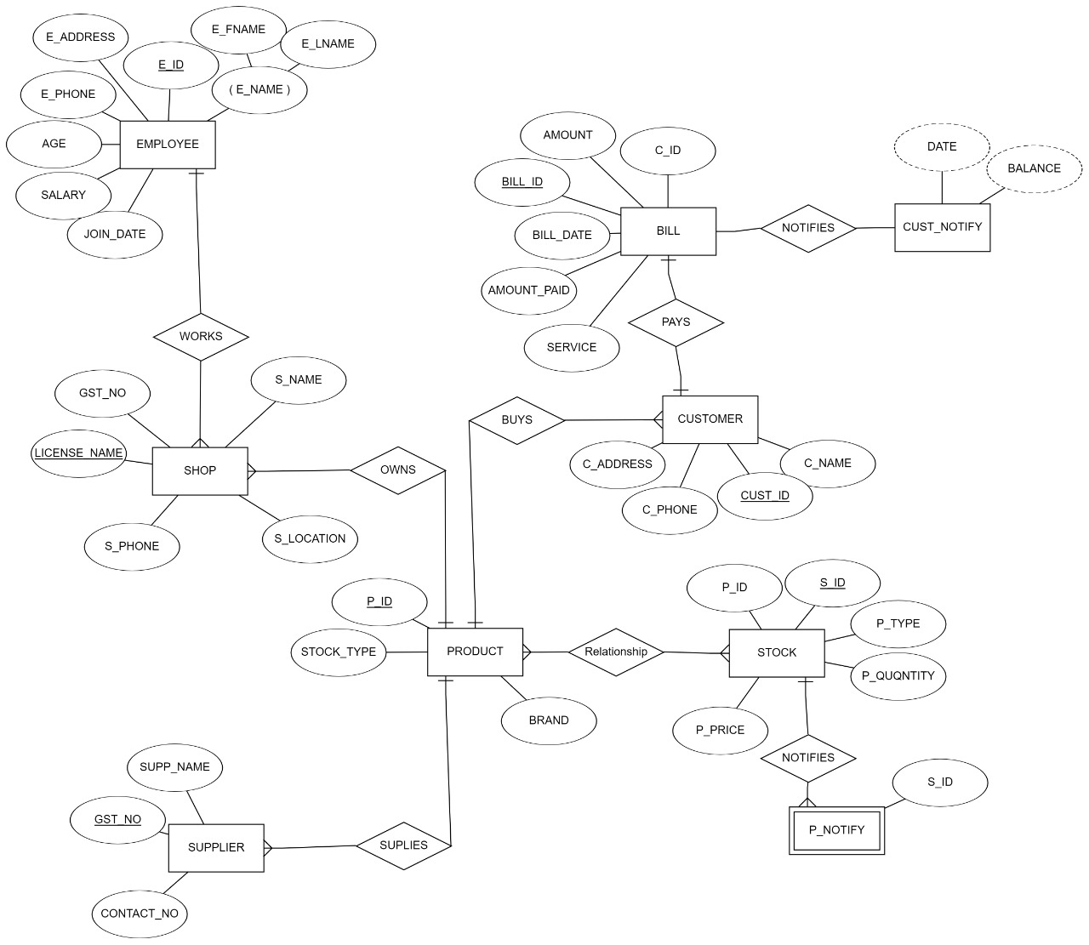

**Question 4:** Choose the **optimal**Entity-Relationship Diagram from the designs provided above and justify why you think this is an optimal solution for your identified problem specification.

We have opted for the **1st ER Diagram** because the requirements as per the entities where in this model.



As in the **2nd ER Diagram** we observe that the products should be connected to bill and then the customer to the bill but we had connected the products and customer and then customer to bill. Hence we rejected this model

In the **3rd ER Diagram** we can see we had created extra entities like notify and stock which are not required and their requirement can be directly fulfilled using appropriate query hence we rejected this model.

Therefore, the model which we have selected as **optimal one** satisfies all the **requirements** with **minimum number of tables.**

**[Optional] Question 5:** Draw an Object Model illustrating the information you have identified in Question 2.

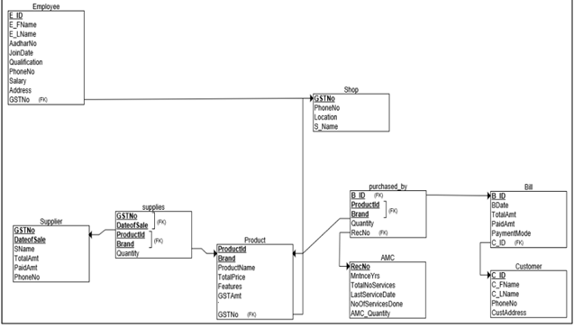

**Question 6:** Draw an ER to Relation Mapping illustrating the information you have identified in Question 4.

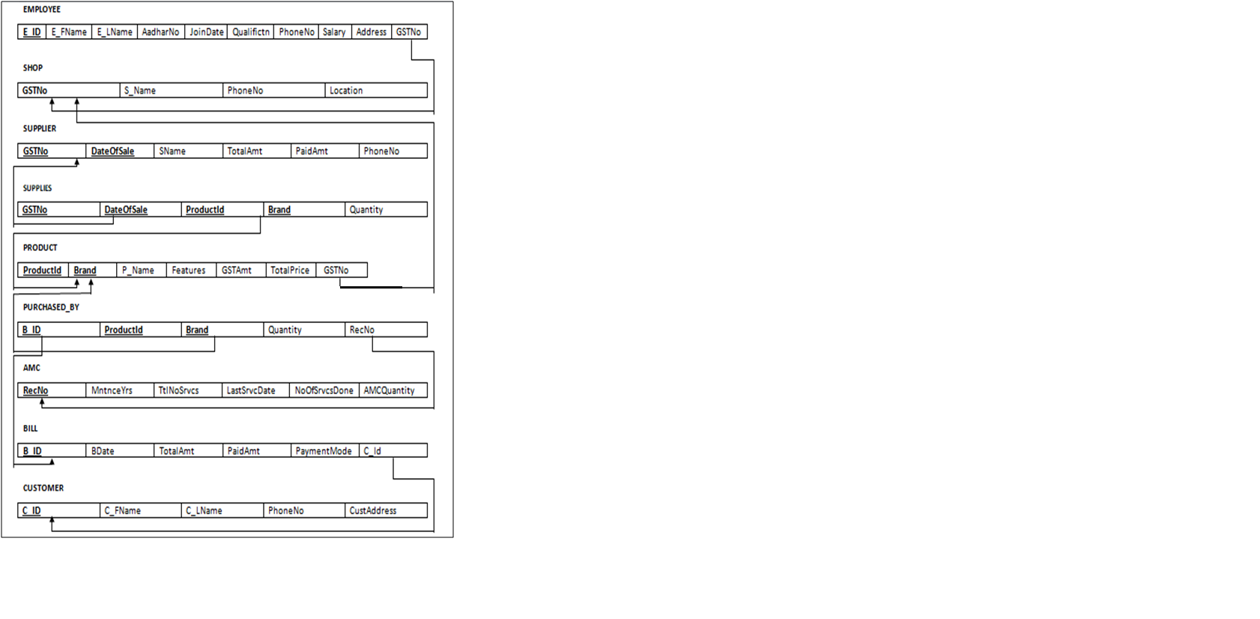

**Question 6:** Draw a Data Dictionary illustrating the information you have identified in Question 6.

|  |  |  |  |  |  |
| --- | --- | --- | --- | --- | --- |
| **Object (Entity)** | **Name (Attribute)** | **Type**  **(Data type)** | **Description** | **Primary Key** | **Foreign Key** |
| Shop | GST_NO | String | Unique identification number for the Shop. | Yes | No |
|  | S_Name | String | Name of the Shop | No | No |
|  | Location | String | Location/Address of the Shop | No | No |
|  | PhoneNo | Integer | Phone number of the Shop | No | No |
| Employee | EmpId | String | Unique identification for each employee | Yes | No |
|  | FName | String | First name of the employee | No | No |
|  | LName | String | Last name of the employee | No | No |
|  | Salary | Integer | Salary of the employee | No | No |
|  | Qualification | String | Qualification of the employee | No | No |
|  | PhoneNo | Integer | Phone number of the employee | No | No |
|  | Address | String | Address of the employee | No | No |
|  | JoinDate | Date | Date on which Employee joined | No | No |
|  | AadharNo | Integer | Unique Aadhar number of the Employee | No | No |
|  | GSTNo | String | GSTnumber of the shop | No | Yes |
| Customer | CustId | String | Unique identification number for the customer. | Yes | No |
|  | C_FName | String | First name of the customer | No | No |
|  | C_LNname | String | Last name of the customer | No | No |
|  | PhoneNo | Integer | Phone number of the customer | No | No |
|  | CustAddress | String | Address of the customer | No | No |
| Product | ProductId | String | Unique id for the product | Yes | No |
|  | Brand | String | Name of the company brand the product belong to | Yes | No |
|  | ProductName | String | Name of the product | No | No |
|  | GSTAmt | Integer | It is the GST amount the product of this brand holds | No | No |
|  | TotalPrice | Integer | Amount Price of the product plus the GST amount which is the total price of that particular product | No | No |
|  | Features | String | Features of the product | No | No |
|  | GSTNo | String | GST number of the shop | No | Yes |
| Bill | Bill_ID | String | Unique id for bill | Yes | No |
|  | BDate | Date | Date of billing | No | No |
|  | TotalAmt | Integer | Total amount generated(including gst) | No | No |
|  | PaidAmt | Integer | Total amount paid | No | No |
|  | PaymentMode | String | Mode of transaction of money | No | No |
|  | CustID | Integer | Id of customer who purchased products | No | Yes |
| Supplier | Gst_no | String | It is the unique number of the supplier | Yes | No |
|  | DateOfSale | Date | Date of sale of products | Yes | No |
|  | SName | String | Name of the product supplying company | No | No |
|  | TotalAmt | Integer | Total amount generated | No | No |
|  | PaidAmt | Integer | Total amount paid to supplier | No | No |
|  | PhoneNo | Integer | Contact number of the supplier | No | No |
| AMC | RecNo | String | Unique id given to each record of amc service | Yes | No |
|  | TotalServices | Integer | Total number of services to be given to customers | No | No |
|  | NoOfServicesDone | Integer | Total number of services already given to customers | No | No |
|  | LastServiceDate | Date | Last service given to customer | No | No |
|  | AMCQuantity | Integer | Quantity of products on which amc is available | No | No |
|  | MaintainenceYears | Integer | Total number of years of service | No | No |
| Supplies | GSTNo | String | Unique identification number for every trader. | Yes | Yes |
|  | DateOfSales | Date | Date on which the goods were bought by the supplier | Yes | Yes |
|  | ProductId | String | Unique id for the product | Yes | Yes |
|  | Brand | String | Name of the company brand the product belong to | Yes | Yes |
|  | Quantity | Integer | Number of particular brand product the supplier brings on that particular date | No | No |
| Purchased_by | B_Id | String | Unique id for bill | Yes | Yes |
|  | ProductId | String | Unique id for the product | Yes | Yes |
|  | Brand | String | Name of the company brand the product belong to | Yes | Yes |
|  | Quantity | Interger | Number of particular brand product the customer buys | No | No |
|  | RecNo | String | Unique id given to each record of amc service | No | Yes |

**References:**

Tool used to draw the ER diagram and object diagram:<https://erdplus.com>

**Design Phase**

**Responsibilities:**

**AnushaRaikar:**

Tables’ creation, insertion of values and Normalization

**ApoorvaJinde:**

GUI implementation and Normalization

**ArchanaBadagi:**

Data collection and Normalized Schema

**AshwiniBanagar:**

Normalized schema and ppt.

**Question 1: Normalization:** Are all the relations in your chosen schema in 3NF? Are they in BCNF? Explain your answers. If any of your relations are not in BCNF, normalize them to BCNF. If you choose to normalize your relations only till 2NF or 3NF, explain your reasons (e.g., the amount of redundancy introduced is limited or some other valid reason).

Entities:

**Employee, Shop,Supplier,Supplies,Product,Purchased_by,AMC,Bill,Customer**

We have the following functional dependencies in the above entities. We have one primary key that so our functional dependency would be

FD of respective entities are as follows

1){E_ID}={E_Id,E_FName,E_LName,AadharNo,JoinDate,Qualification,PhoneNo,Salary,Address,GSTNo }

2){GSTNo}={GSTNo,S_Name,PhoneNo,Location }

3){GST_no**,**DateOfSale,ProductId,Brand}={GST_no**,**DateOfSale,ProductId,Brand**,**Quantity}

4){ProductId,Brand}={ProductId,Brand**,**P_Name**,**TotalQuantity**,**GSTAmt**,**TotalPrice**,**Features,GSTNo}

**5)**{Bill_ID}={Bill_ID**,**BDate**,**PaidAmt**,**TotalAmt**,**PaymentMode,CustId}

6){CustId}={ CustId,C_FName,C_LName,PhoneNo,CustAddress}

7){RecNo}={RecNo,AMCQuantity,MaintenanceYears,TotalNoServices,NoOfServicesDone,LastService}

8){B_Id,ProductId,Brand}=){B_Id,ProductId,Brand,Quantity,RecNo}

* The above entities has all its attributes as single or atomic values hence we conclude that the following relation is 1NF
* As we see there is no partial dependency and total dependency so the table has no 2nf hence all tables are 1nf .

In the entity **Supplier**

* 1NF:The above entitiy has all its attributes as single or atomic values hence we conclude that the following relation is 1NF.
* 2NF:

FD1:{GSTNo}={GSTNo,SName,PhoneNo}

FD2:{GSTNo,date}={GSTNo,DateOfSale,TotalAmt,PaidAmt,PhoneNo }

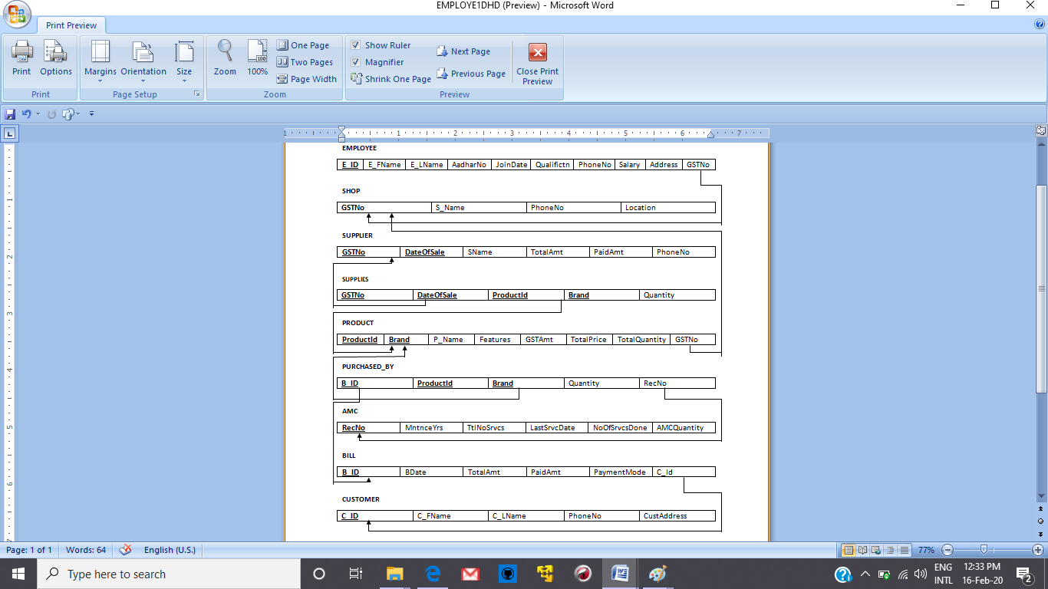

This table can be decomposed into

Supplier_Detail:

|  |  |  |
| --- | --- | --- |
| **GSTNo** | SName | PhoneNo |

Supplier_Transaction:

|  |  |  |  |  |
| --- | --- | --- | --- | --- |
| **GSTNo** | **DateOfSale** | TotalAmt | PaidAmt | PhoneNo |

* Considering the following two FD’s there doesn’t exist transitivity among the given FD’s and hence they are not in 3NF
* Hence the above schema is in 2NF.

**Question 2:** Choose the **optimal** normalized schema from Question 1 and justify why you think this is an optimal solution.

We think that the normalized schema of Supplier is more Optimal compared to the de-normalized form as we can reduce the redundancy by keep it in normalized form. Though we could not remove the redundancy completely but doing so we can remove most of the redundancy.

So we have normalized all the schemas in 1NF, 2NF.

**Question 3:** User Interface (UI) design

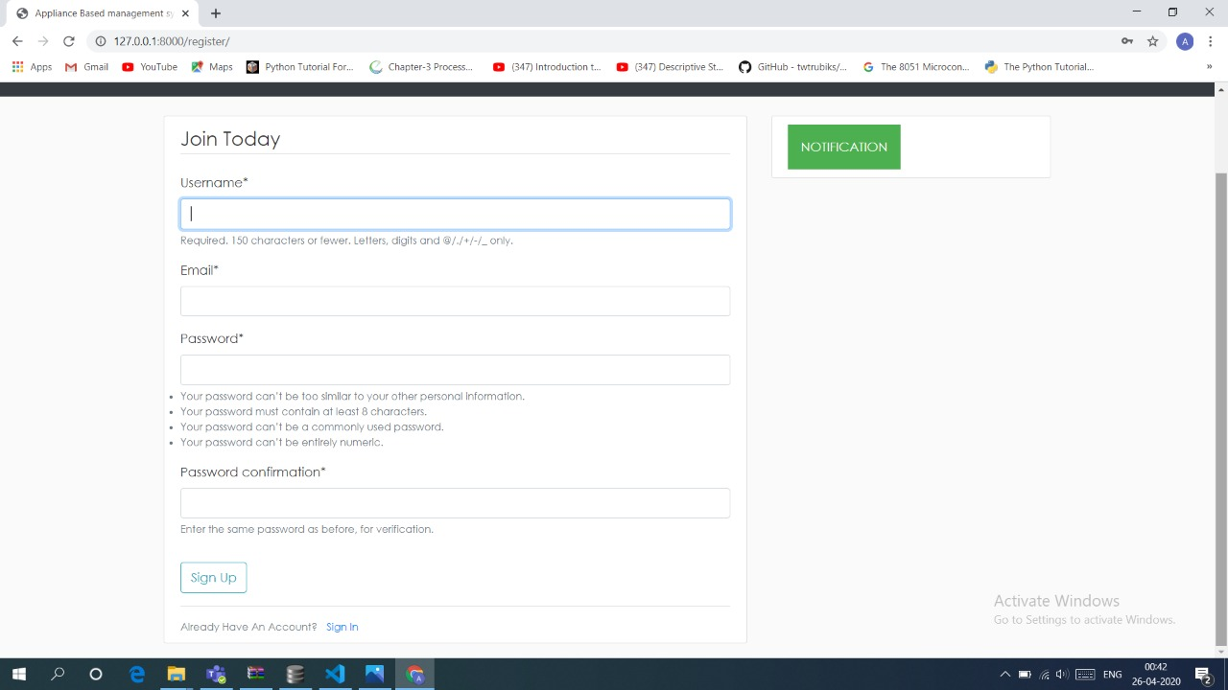 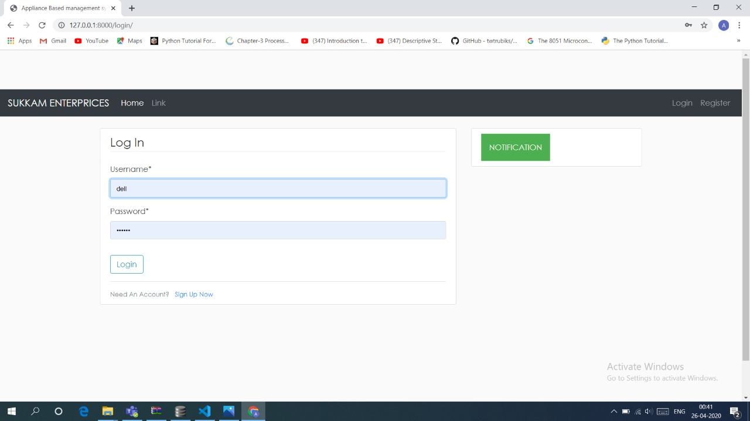 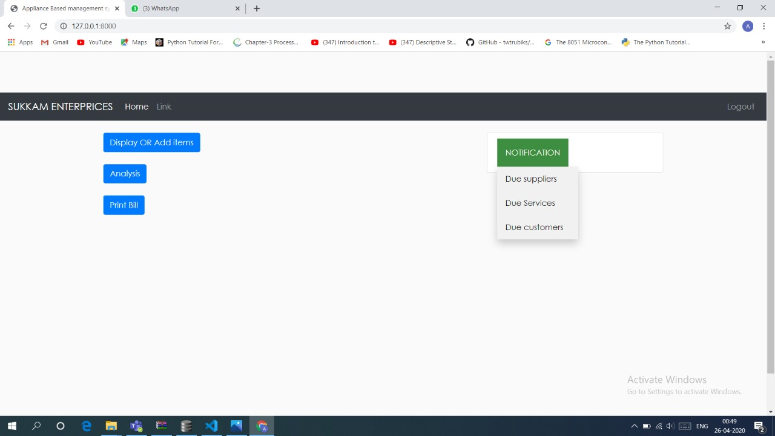

KLETech/SoCSE(2019-20)/DBMS/15ECSC208/Course Project/Report/Page 18 of

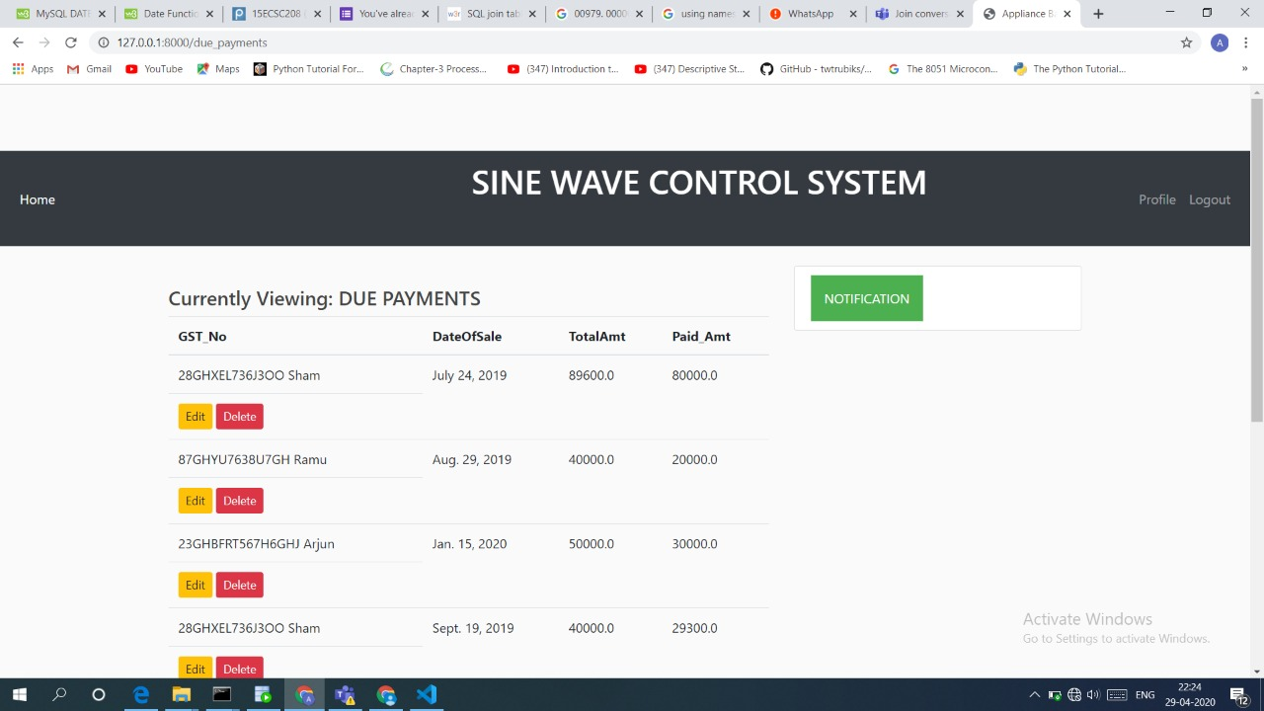

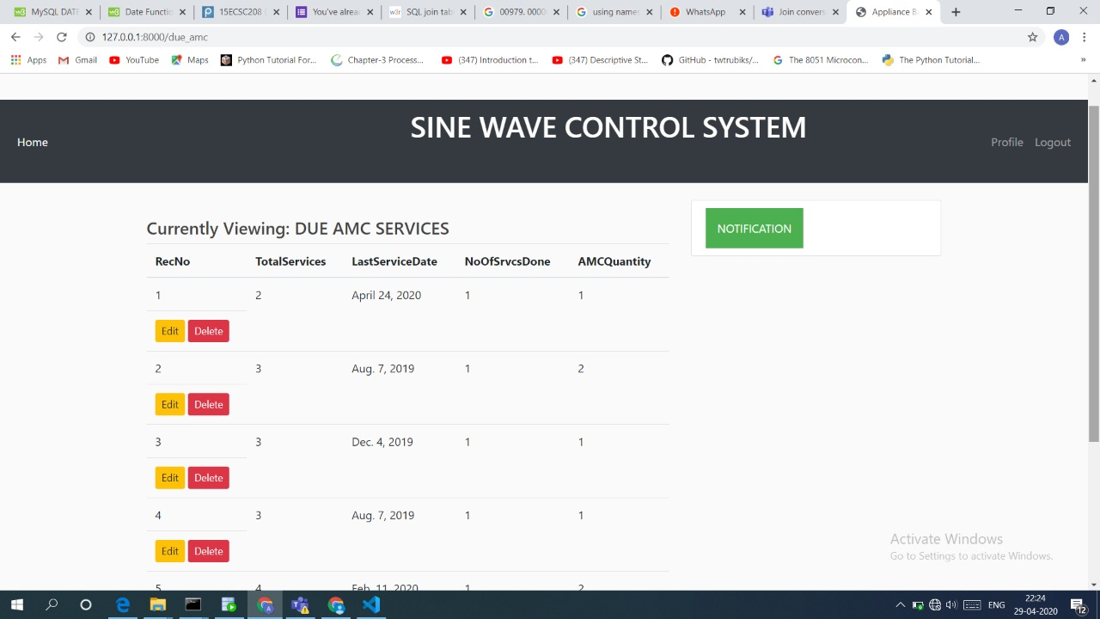

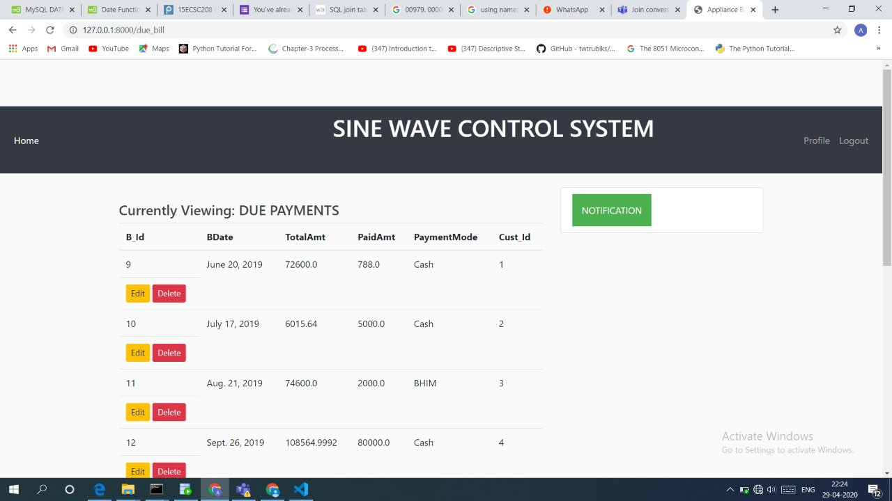

**Question 4:** Implemented requirements completed till date (if any)

1. Details about price of the product,Employees,Suppliers.

2. Details about Customer and their Accounts.

3. Proper security of all data.

**References:** Django official documentation, GitHub

**Implementation Phase**

**Responsibilities:**

**AnushaRaikar:**

Collection of all data from the clients required for the project. Insertion of values GUI validations done.

**ApoorvaJinde:**

GUI implementation, Exceptions handling, plotting graphs.

**ArchanaBadagi:**

Interaction with the client.GUI frames, connections based on URL pathing

**Ashwini Banagar:**

GUI frames, connections and documentation done, final ppt prepared and designing of the web pages.

**Question1:** Give the SQL statement(s) used to create the Oracle/MySQL database tables needed to implement the normalized relational schema.

CREATE TABLE amc (

RecNo varchar2(10) NOT NULL PRIMARY KEY,

MaintenanceYears int NOT NULL,

TotalServices int NOT NULL,

LastServiceDate date NOT NULL,

NoOfSrvcsDone int NOT NULL,

AMCQuantity int NOT NULL

);

CREATE TABLE customer (

C_Id varchar2(10) NOT NULL PRIMARY KEY,

C_Fname varchar2(20) NOT NULL,

C_Lname varchar2(20) NOT NULL,

PhoneNumber int NOT NULL,

CustAddress varchar2(50) NOT NULL

);

CREATE TABLE shop (

GSTNo varchar2(17) NOT NULL PRIMARY KEY,

S_Name varchar2(30) NOT NULL,

PhoneNint NOT NULL,

Location varchar2(100) NOT NULL

);

CREATE TABLE supplier_detail(

GSTSupplier varchar2(20) NOT NULL PRIMARY KEY,

S_Name varchar2(20) NOT NULL,

ContactNo int NOT NULL

);

CREATE TABLE supplier_transaction(

id int NOT NULL PRIMARY KEY AUTOINCREMENT,

DateOfSale date NOT NULL,

TotalAmt int NOT NULL,

Paid_Amt int NOT NULL,

GST_No_idvarchar2(20) NOT NULL

foreign key (GST_No_id) referencessupplier_detail(GSTSupplier)

);

CREATE TABLE product (

id int NOT NULL PRIMARY KEY AUTOINCREMENT,

ProductId varchar2(10) NOT NULL,

Brand varchar2(10) NOT NULL,

P_Name varchar2(50) NOT NULL,

Features varchar2(100) NOT NULL,

GSTAmt int NOT NULL,

TotalPriceint NOT NULL,

GSTnoShop_id varchar2(17) NOT NULL

foreign key (GSTnoShop_id) references Shop (GSTNo)

);

CREATE TABLE employee_details (

Empid varchar2(10) NOT NULL PRIMARY KEY,

E_FName varchar2(15) NOT NULL,

E_LName varchar2(15) NOT NULL,

AadharNo int NOT NULL,

JoinDate date NOT NULL,

Qualification varchar2(20) NOT NULL,

PhoneNo int NOT NULL,

Salary int NOT NULL,

Address varchar2(100) NOT NULL,

GSTnoShop_id varchar2(17) NOT NULL

foreign key (GSTnoShop_id) references Shop (GSTNo)

);

CREATE TABLE bill(

B_Id varchar2(15) NOT NULL PRIMARY KEY,

BDate date NOT NULL,

TotalAmt int NOT NULL,

PaidAmt int NOT NULL,

PaymentMode varchar2(10) NOT NULL,

Cust_Id_id varchar2(10) NOT NULL

foreign key (Cust_Id_id) references customer (C_Id)

);

CREATE TABLE supplies (

id int NOT NULL PRIMARY KEY AUTOINCREMENT,

Quantity int NOT NULL,

pro_info_id int NOT NULL

foreign key (pro_info_id) references product(id)

supp_info_id int NOT NULL

foreign key (supp_info_id)referencessupplier_transaction(id)

);

CREATE TABLE purchase(

id int NOT NULL PRIMARY KEY AUTOINCREMENT,

Quantity_purchase int NOT NULL,

Rec_no_id varchar2(10) NOT NULL

foreign key (Rec_no_id)referencesamc (RecNo)

bill_info_id varchar2(15) NOT NULL

foreign key (bill_info_id)referencesbill (B_Id)

prod_info_id int NOT NULL

foreign key (prod_info_id)references product(id)

);

**Question2:** Give the actual data stored in each table of the database. (real sample data)

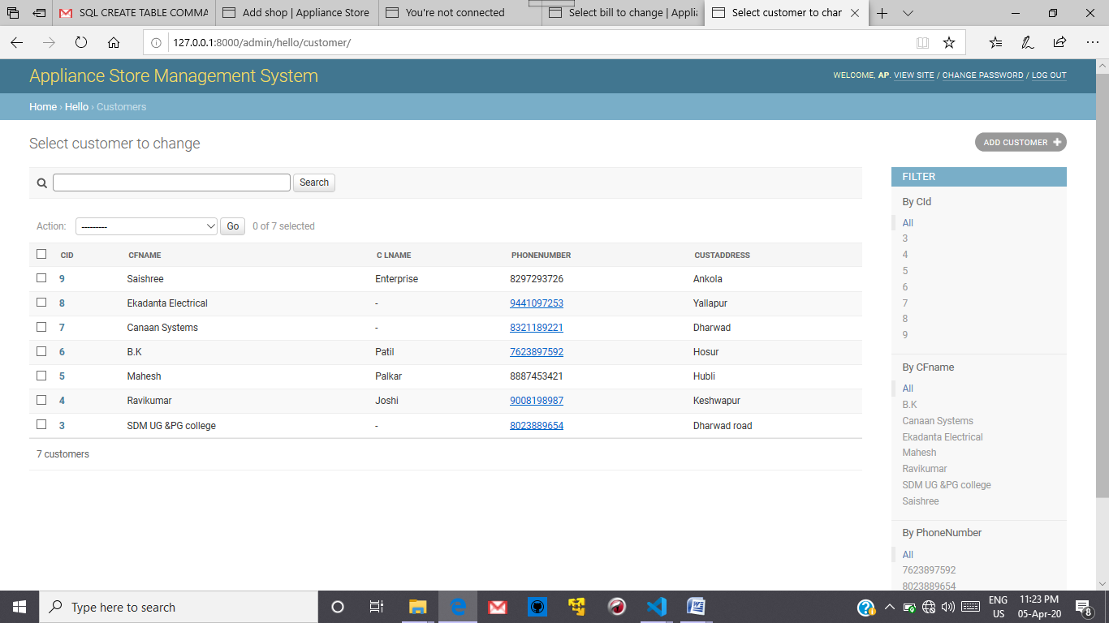

Figure .Customer Table

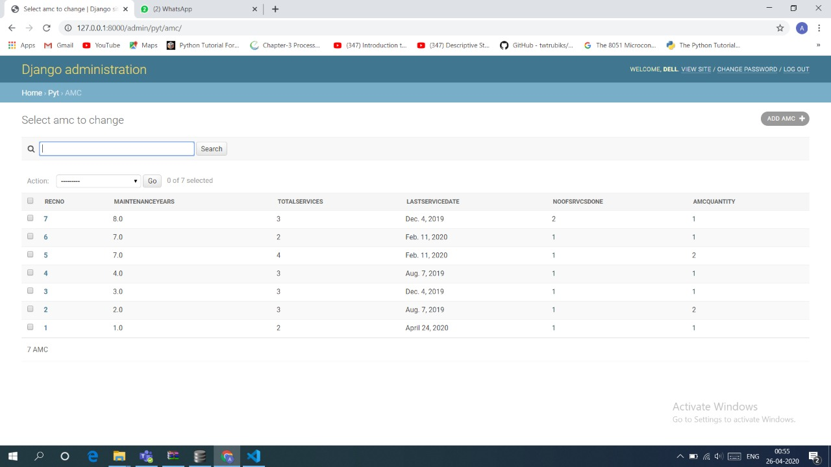

Figure AMC table

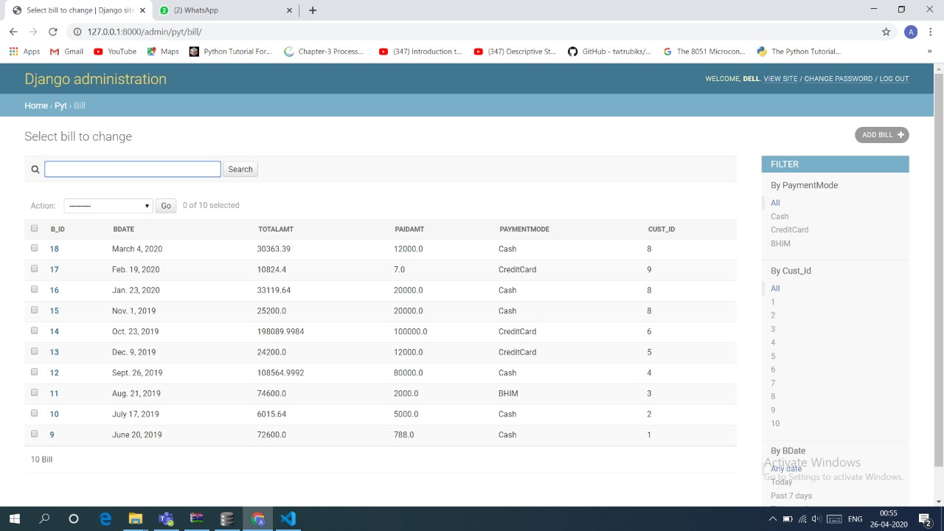 Figure 3 Bill Table

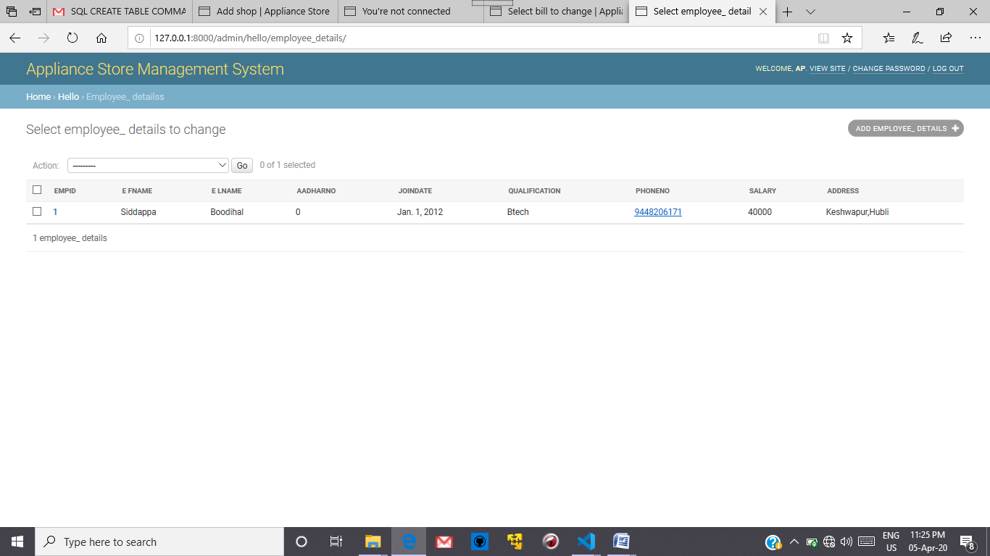

Figure Employee Table

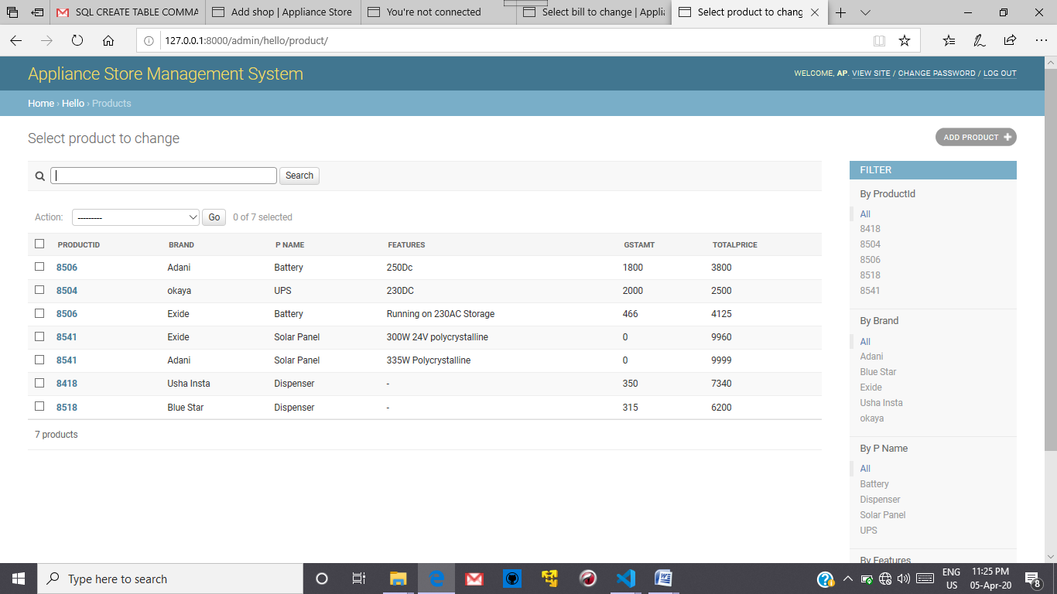

Figure Products Table

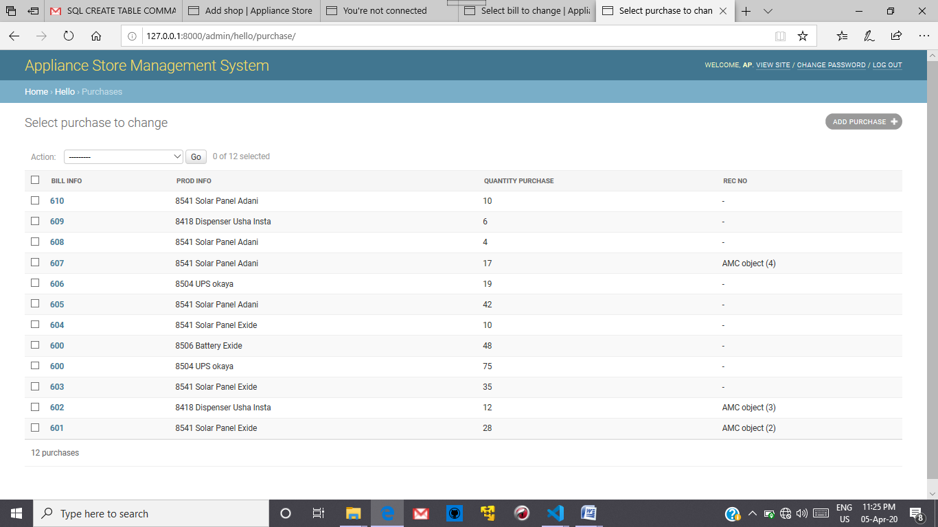

Figure Purchases Table

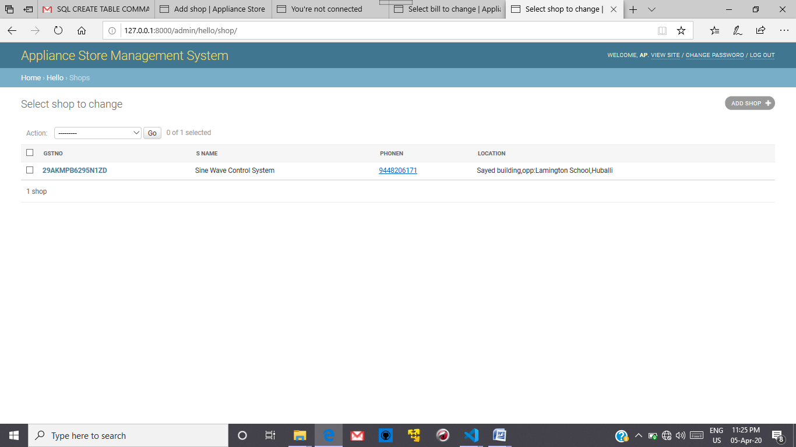

Figure Shop Details Table

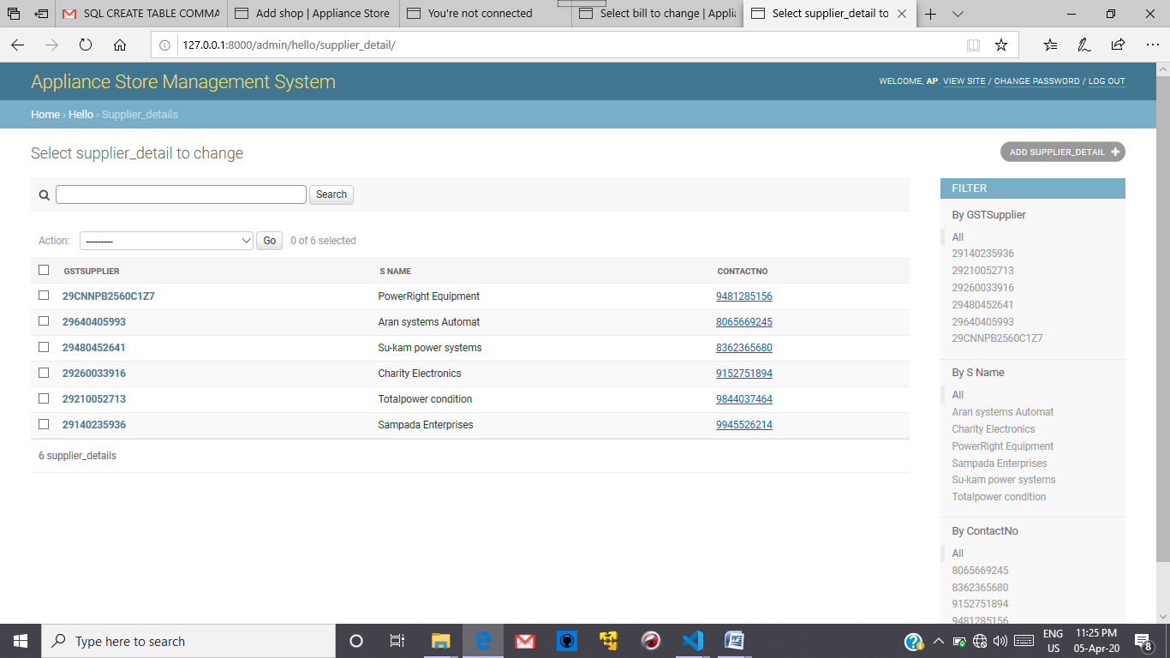

Figure Supplier_Details Table

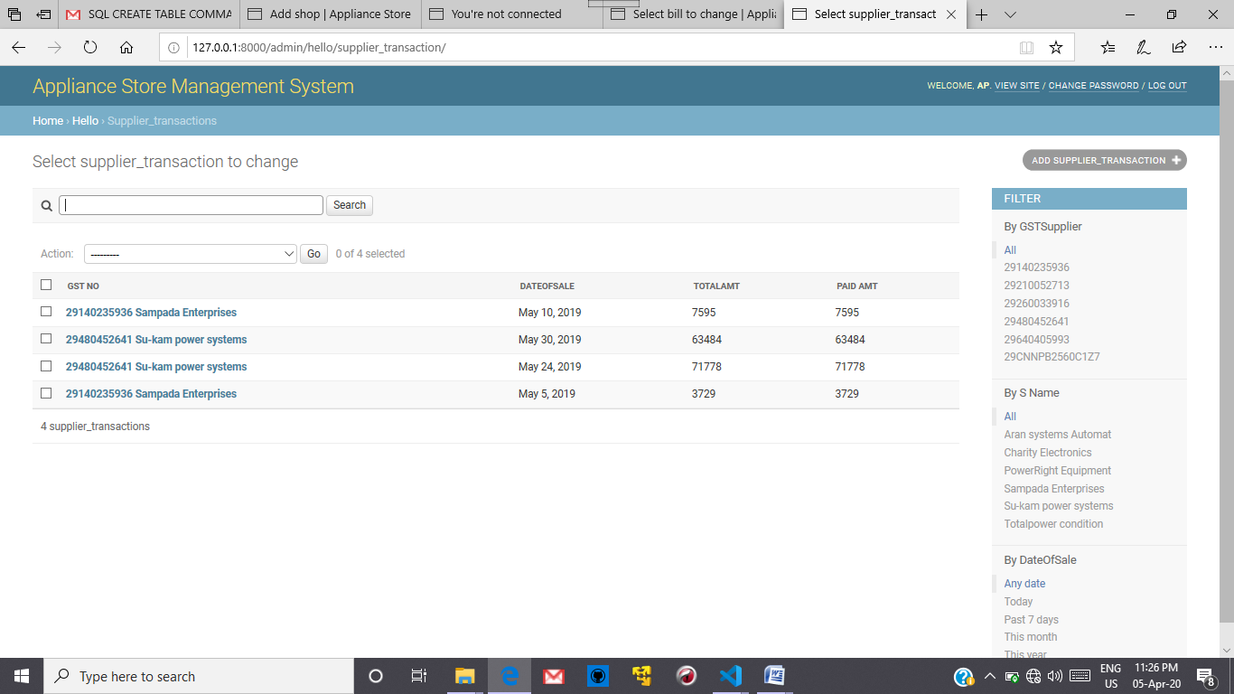

Figure Supplier_Transaction Table

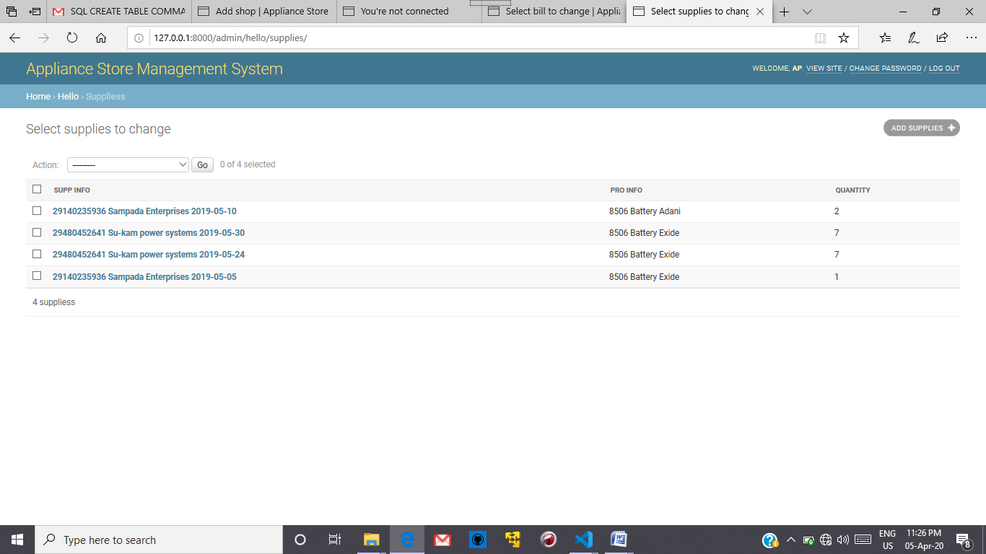

Figure Supplied Item Table

**Question3:** Give the snapshots, description and SQL queries for each of the user interface forms for your application. (Create the front end using Django and hook it up to the SQL.)

1) for details of customers in bill generated

q = Bill.objects.raw('SELECT * FROM Customer as C ,Bill as B WHERE C.C_Id=B.Cust_Id_id and B.B_Id=%s',[bill_no])

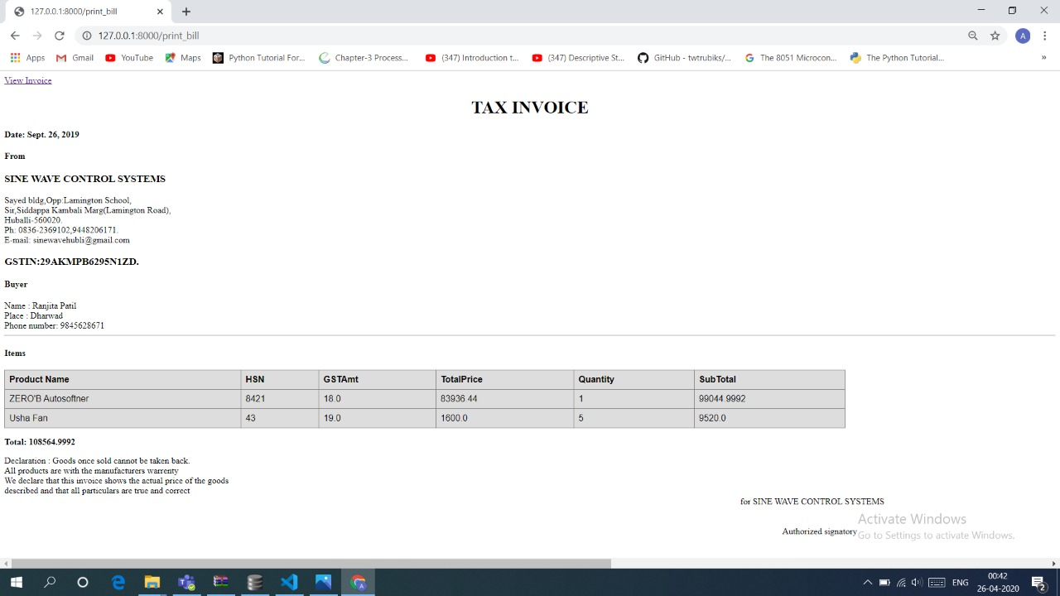

2)for details of product in bill generated

a = Product.objects.raw('SELECT * FROM Product as PR,Purchase as P WHERE PR.id=P.prod_info_id and P.bill_info_id=%s' ,[bill_no])



Both 1st and 2nd queries are included in a single view.

3)for details of due payments to suppliers

a=Supplier_transaction.objects.raw('SELECT * FROM Supplier_transaction WHERE Paid_Amt<TotalAmt')



4)for details of due payments of customers

a=Bill.objects.raw('SELECT * FROM Bill WHERE PaidAmt<TotalAmt')



5)for due amc services

a=AMC.objects.raw('SELECT * FROM AMC WHERE NoOfSrvcsDone<TotalServices')



6)for sales graph

c.execute('SELECT substr(DateOfSale,1,7) as "Month", sum(TotalAmt) as Amount from Supplier_transaction group by substr(DateOfSale,1,7)')

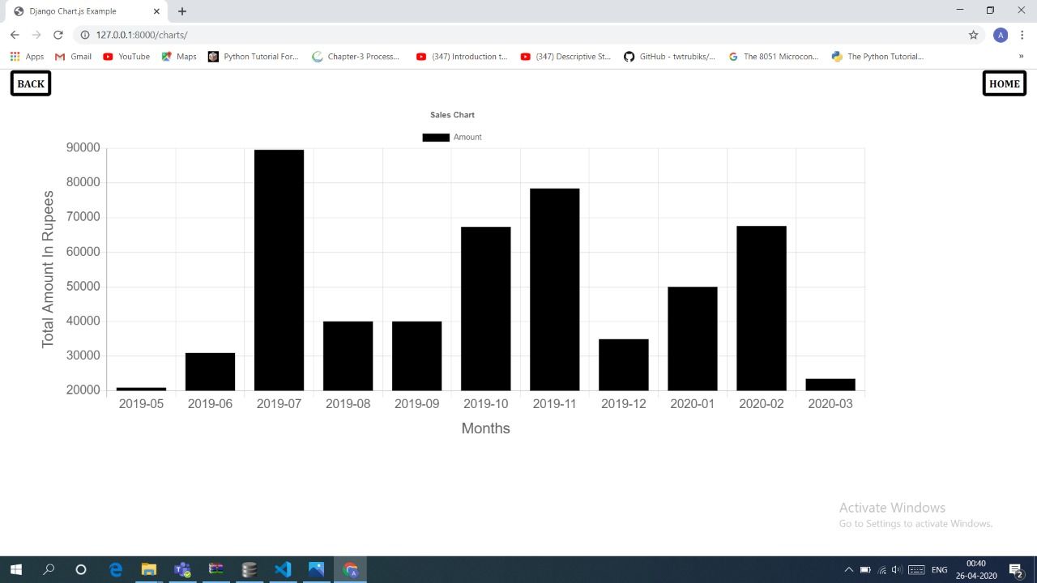

7)for purchase garph

c.execute('SELECT substr(BDate,1,7) as "Month", sum(TotalAmt) as Amount, B_Id from Bill group by substr(BDate,1,7)')

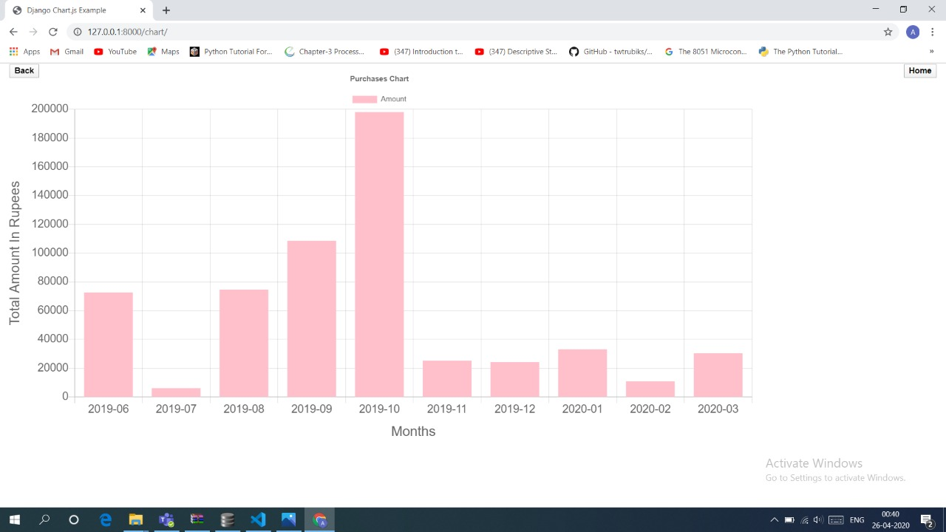

**Question4:** Give all possible final bill reports/other forms of ledger reports summarized etc and graphs obtained by your application.

This is the bill with automated calculation we get after entering the bill number 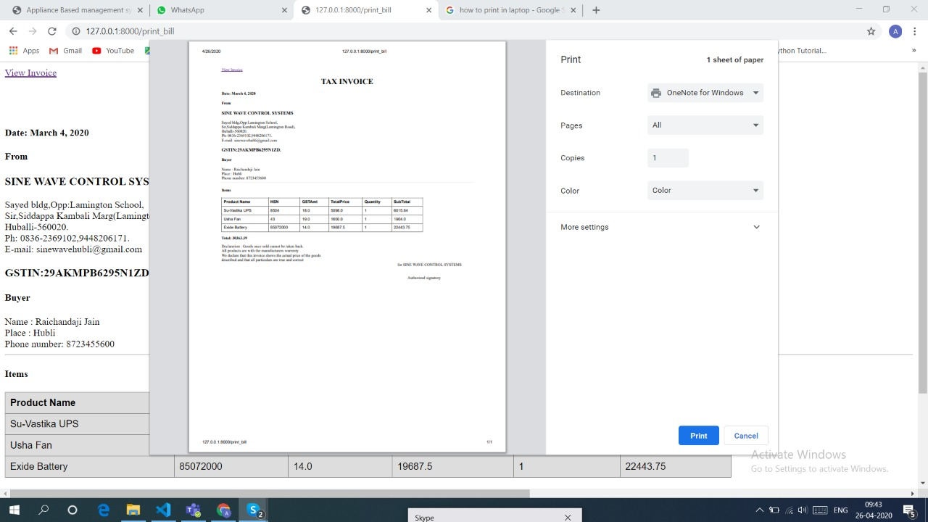

To convert to the pdf we need to click the button view invoice at the corner so that the pdf of the bill is generated



This is the annual Sales Report for the previous year



Purchase Analysis of the goods by the customers in the previous year

**Question5:** Any other matter you wish to add can do so (if necessary)

We have handled a few exception cases like phone number length validation, negative number validation.

Conditional validations like total amount cannot be less than paid amount , quantity purchased cannot be less than amc quantity are handled.

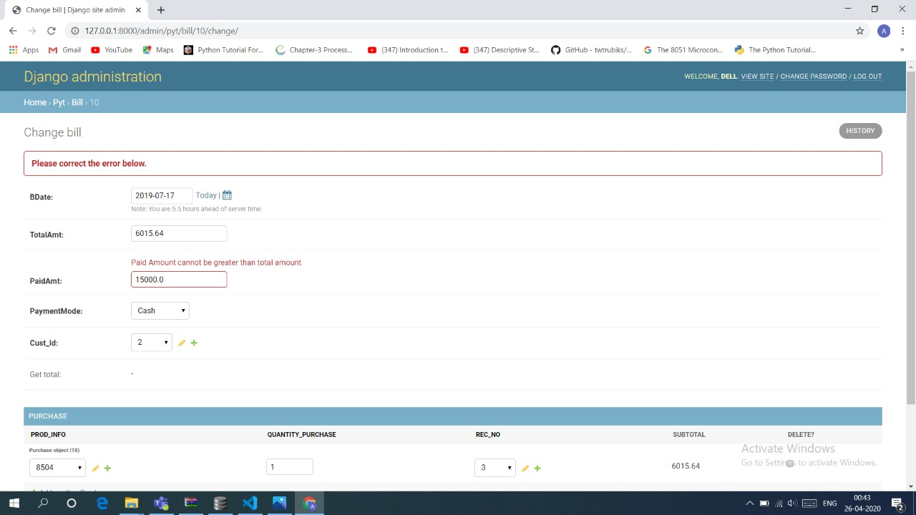

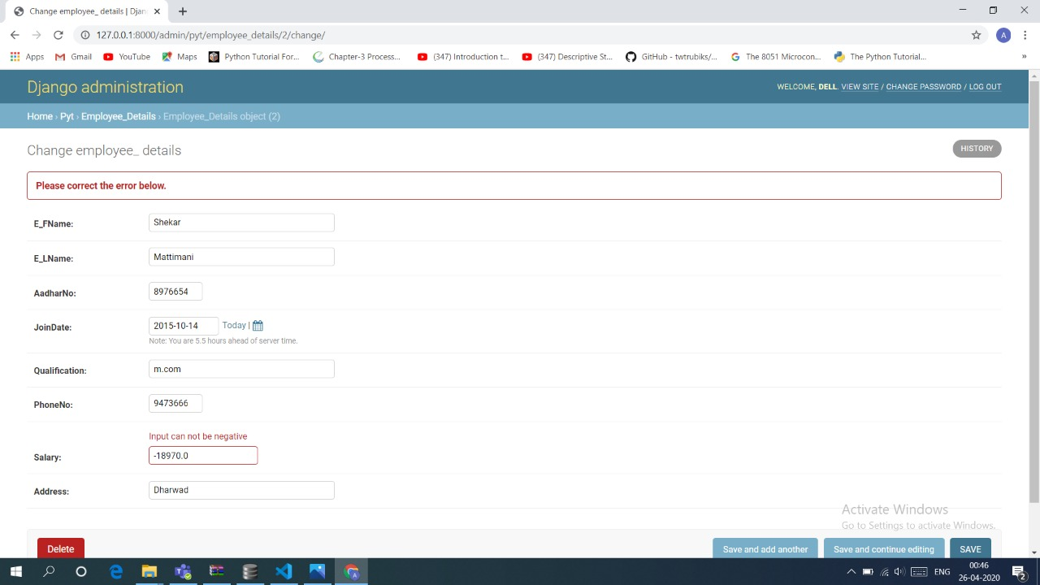

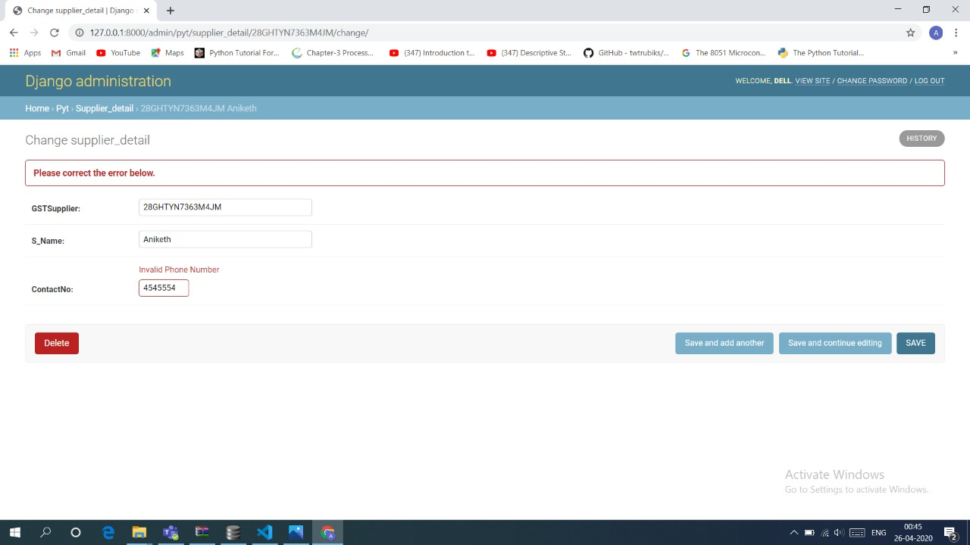

**READ ME:**

DATABASE SYSTEM README

======================

This is the README file for the Database System of Appliance Store Management System.

If you're reading this you've probably installed this application on your system.

What should I do next?

---------------------

If you want to use this application you should first install django version>3 and python 3.8 Username and password for the login page is username :dell ,password :anusha

For database username is: and password:

This will give the access to use the application.

Hope you will not encounter any difficulties using this application as all the errors have been

handled by appropriate messages.

**Photo Snapshots**

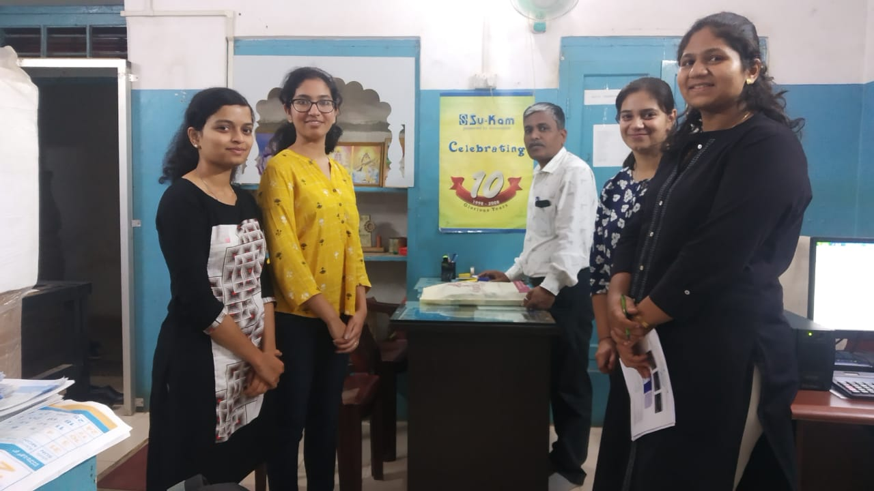

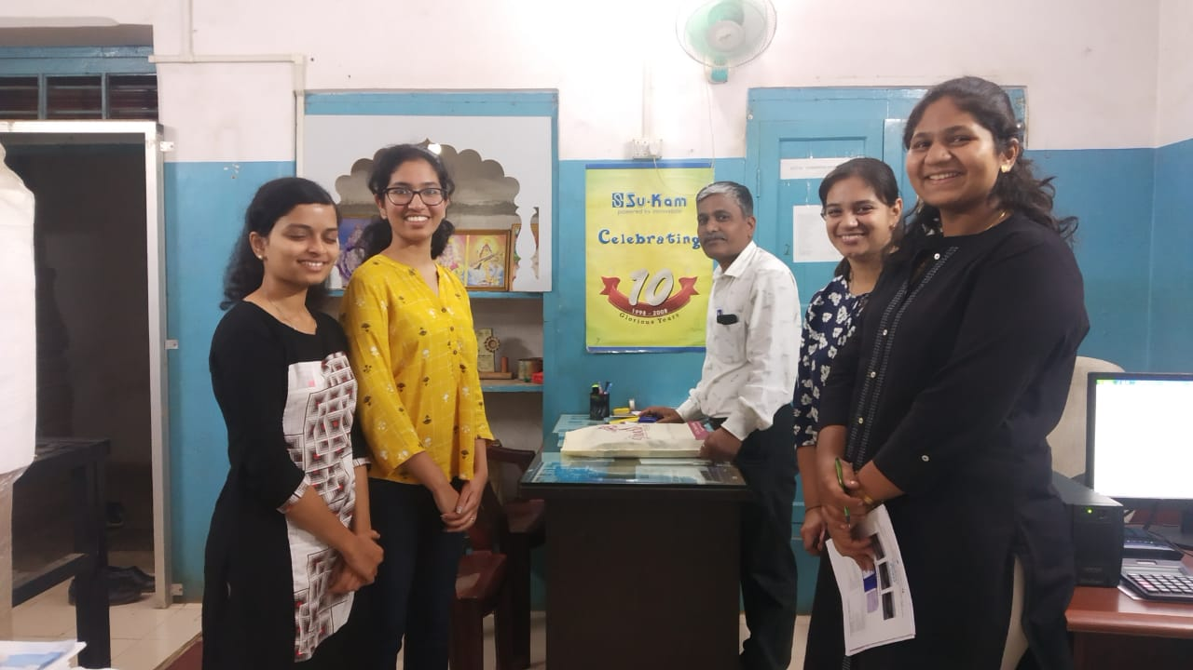

Snapshots with client

**Dataset Snapshots**

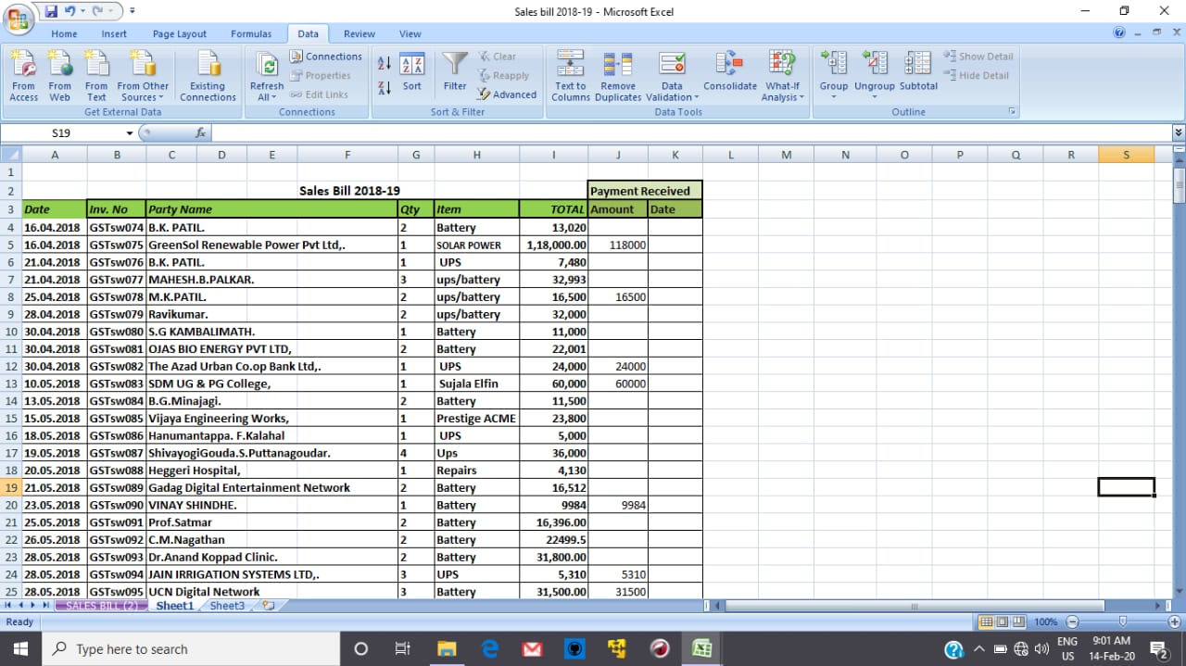

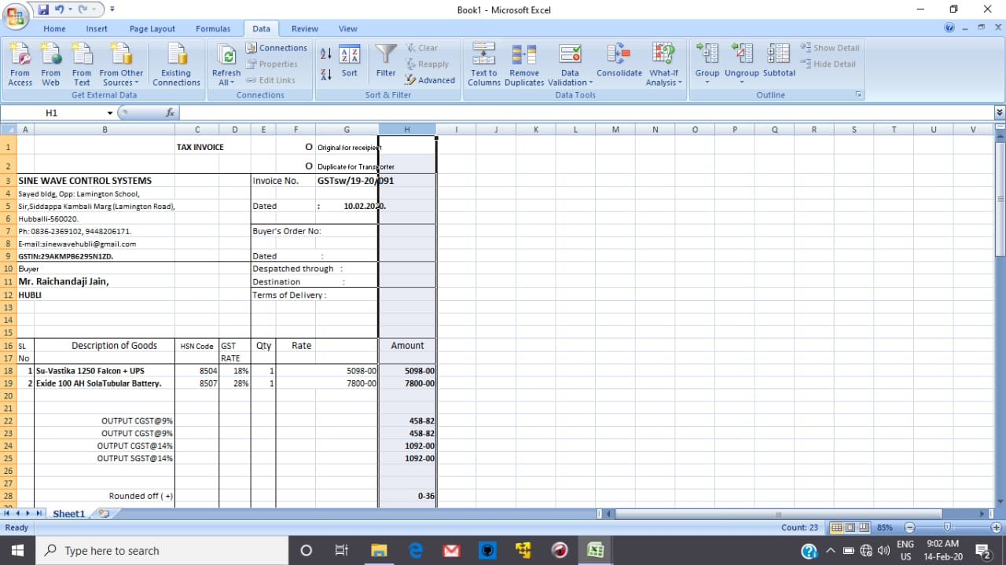

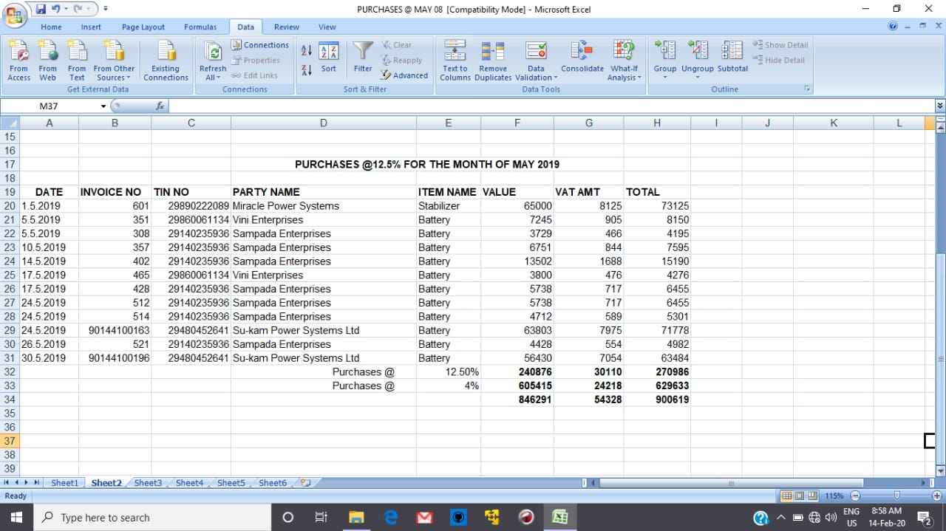

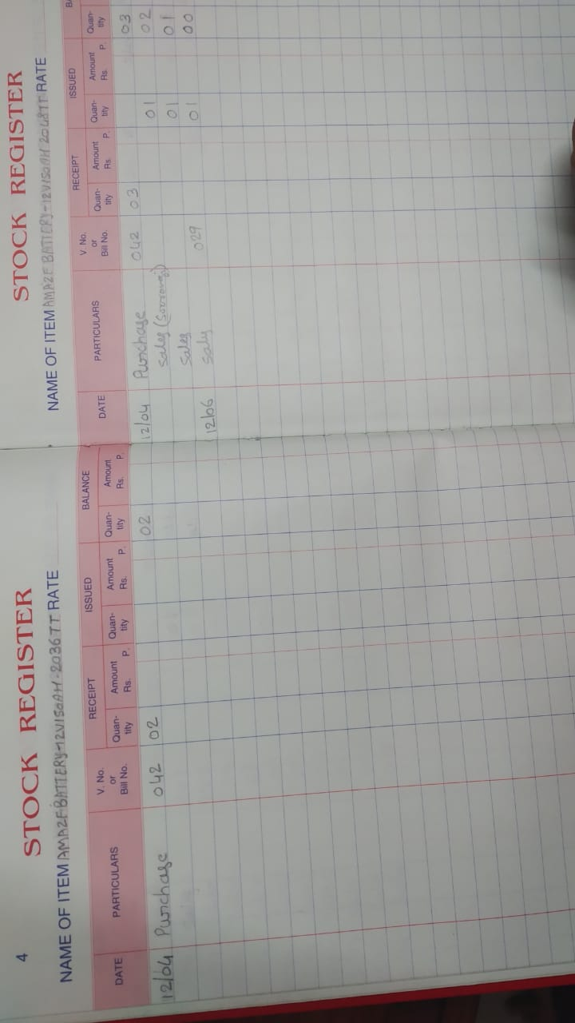

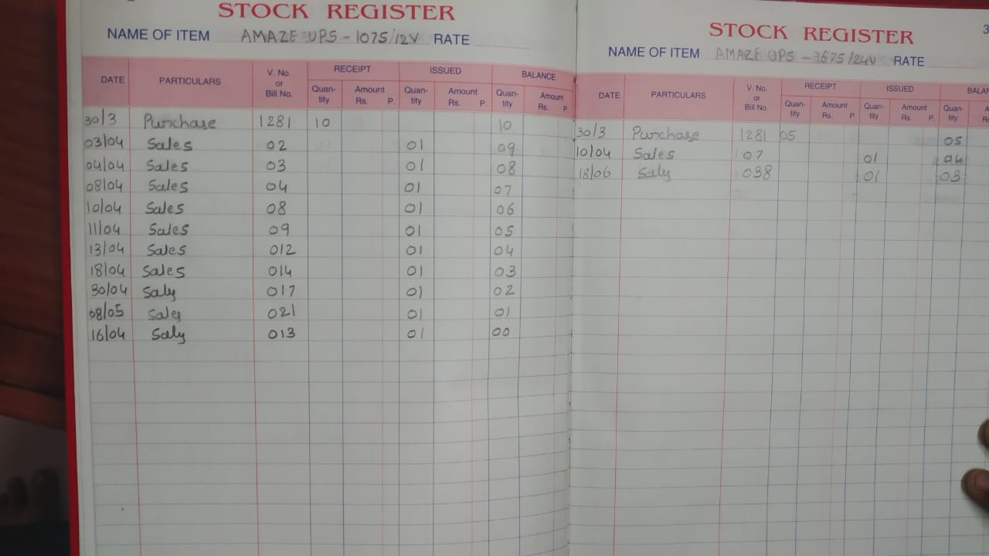

Records are maintained in excel files and ledgers presently.

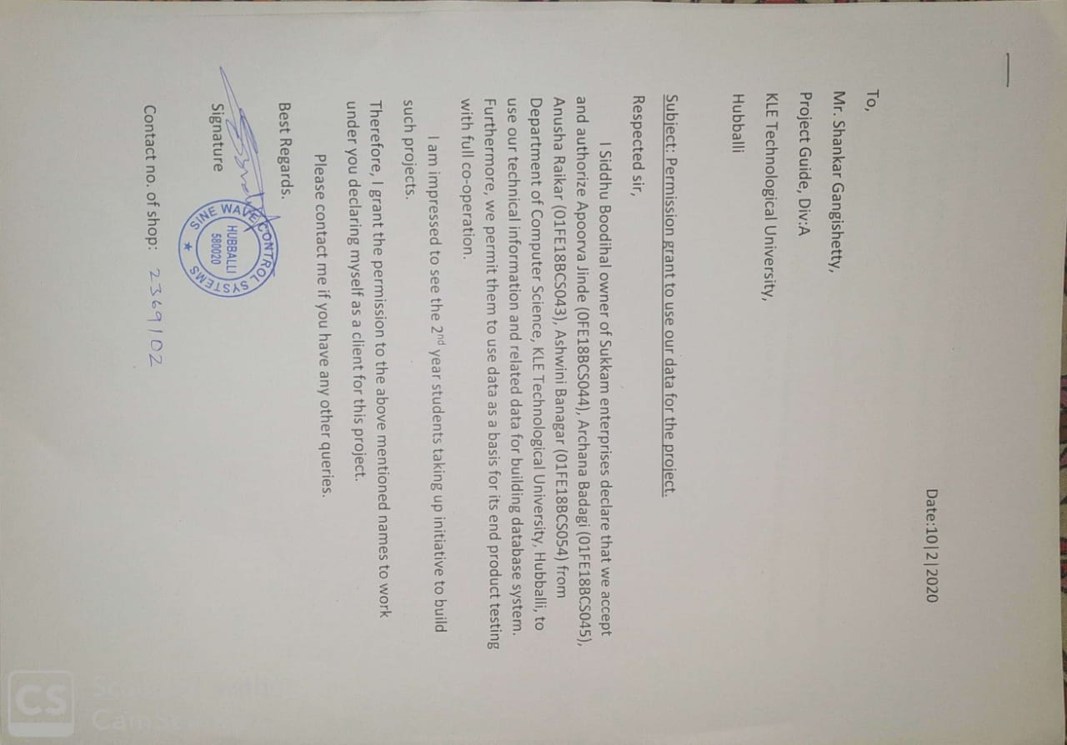**Acceptance Letter**

**CUSTOMER FEEDBACK:**

These are some points which we have collected from our client as a feedback:

This will make our work easy and I hope we will be installing this application to all of our systems.

The work done by the students on data section is also the best solution. By using this we are able to see the raise and fall in the account graphically.

The systematic analysis of the bills and the addition of the new parties and suppliers is also done well.

This application has reduced the writing work and loosing of the data.

We thank the students for giving such a beautiful application and I hope, in future also they will be helping the society with their knowledge.

